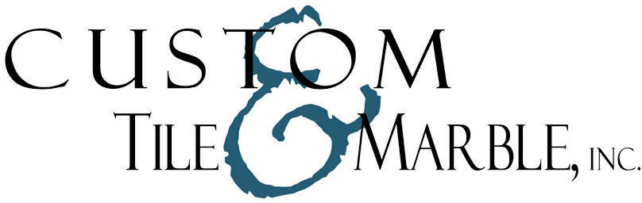

# EAST WEST MARBLE

**9220 Edgeworth Dr. Capitol Heights, MD 301-456-7072**

[**www.ewmarble.com**](http://www.ewmarble.com/) **M-F: 8:30-4:00**

**SAT: APT ONLY**

# GRAMACO

**8730 Greenwood Place Unit C Savage, Md. 20763 240-456-0030**

[**www.gramaco.com**](http://www.gramaco.com/) **M-F: 8:00-4:30**

# MARVA

**12225 Distribution Way Beltsville, MD 20705**

**800-929-6278**

[**www.marvamarble.com**](http://www.marvamarble.com/) **M-F: 8:00-4:30**

**SAT: 10:00-1:00**

# M S INTERNATIONAL

**7595 Montevideo Rd. Ste. 200 Jessup, Md. 20794**

**410-799-9631**

[**www.msistone.com**](http://www.msistone.com/) **M-F: 8:00-5:00**

**SAT: 9:00-12:00**

**STONE ACTION**

**9010 Maier Rd #112 Laurel, MD 20723**

**240 456-0792**

[**www.stoneaction.net**](http://www.stoneaction.net)

**M-F: 8:00 – 5:00**

Please note that not all distributors are open on Saturdays. We suggest you contact the distributor to make an appointment for Saturdays. Also, various locations are closed for holidays. We recommend you contact the distributor prior to your visit. In stock status does not guarantee availability. Out-of-stock status is only applicable to the lot shown: other lots of the same material may be available. Please verify size, quantity and availability by calling prior to making any decisions related to material. Thank you.

**Custom Tile Works**

**32744 Old Ocean City Road Parsonsburg, MD 21849 410-749-8098**